At the Airport: Customs
Airport Role-play: You are going to be a traveler going through customs. Visit as many countries as you can and write down which countries you visited.  A: Welcome to Canada. May I see your passport please?  B: Sure. Here it is.  A: Where are you coming from?  B: I’m coming from Seoul, Korea.  A: What is the purpose of your visit?  B: I’m here on business.  visiting relatives.  here as an exchange student.  here as a tourist.  A: How long are you planning to stay?  B: I’ll be staying for three weeks.  for 1 month.  until tomorrow.  until next Tuesday.  A: Where will you be staying?  B: I’ll be staying at a hotel.  at my aunt’s house.  at a dormitory.  A: Have you ever been to Canada before?  B: No, this is my first time.  A: Do you have anything to declare?  B: No, nothing.  A: Enjoy your stay.  B: Thank you. | 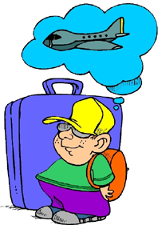
Countries Visited:
_____________________________  _____________________________  _____________________________  _____________________________  _____________________________  _____________________________  _____________________________ | _____________________________  _____________________________  _____________________________  _____________________________  _____________________________  _____________________________  _____________________________
www.bogglesworldesl.com

