Airport Role-play:  Customs Sheet A |  | Role-play: You are a customs and immigration officer at an airport. When students try to enter your country find out this information. To the left of the table there are some questions that you might want to ask. Fill in the blanks with a country name. | 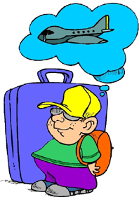

Welcome to _________.  May I see your passport?  Where are you coming from?  What is the purpose of your visit?  How long are you planning to stay?  Where will you be staying?  Is this your first time to ________?  Do you have anything to declare?  Enjoy your stay. |  | Name | Nationality | Last Country Visited | Purpose of Visit | Intended Length of Stay | Location of Stay | Anything to Declare (Y/N) | First Time (Y/N)
www.bogglesworldesl.com
Airport Role-play:  Customs Sheet B |  | Role-play: You are a customs and immigration officer at an airport. When students try to enter your country find out this information. To the left of the table there are some questions that you might want to ask:

Welcome to _________.  Could I see your passport?  Where are you coming from?  Why are you visiting ________?  How long do you intend to stay?  Where will you be staying?  Have you been to ________ before?  Do you wish to declare anything?  Enjoy your stay. |  | Name | Nationality | Last Country Visited | Purpose of Visit | Intended Length of Stay | Location of Stay | Anything to Declare (Y/N) | First Time (Y/N)
www.bogglesworldesl.com

