AROUND THE CITY
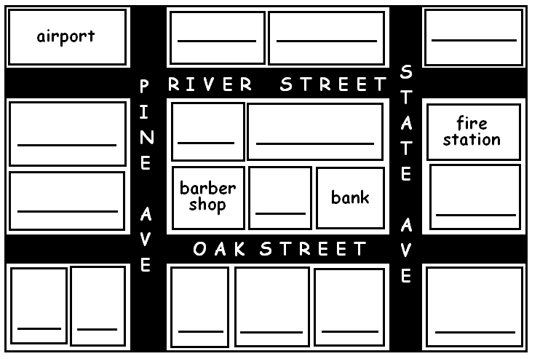
There’s a bakery between the barber shop and the bank.
There’s a department store across from the airport.
There’s a park behind the barber shop.
There’s a drug store on River St. across from the park.
There’s a library next to the drug store.
There’s a train station around the corner form the department store.
There’s a clinic across form the train station.
There’s a library next to the clinic.
There’s a restaurant on Oak St. across from the barber shop.
There’s a supermarket between the restaurant and the hotel.
There’s a Laundromat next to the park.
There’s a post office a cross form the fire station.
There’s a hotel around the corner from the fire station.
There’s a movie theater across from the hotel.

