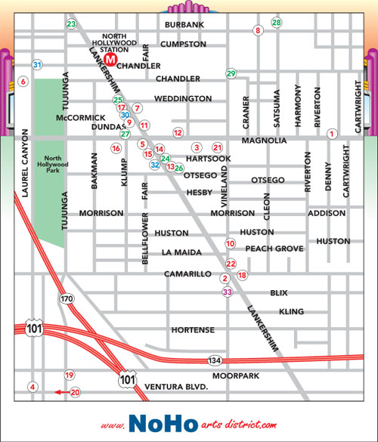
You are at point 1, and you need to get to point 28; How do you get there?
________________________________________________________________________________________________________________________________________________________________________________________________________________________
You’re at point 33, and you need to get to point 12; How do you get there?
________________________________________________________________________________________________________________________________________________________________________________________________________________________
You’re at point 4, and you need to get to point 8; How do you get there?
________________________________________________________________________________________________________________________________________________________________________________________________________________________

