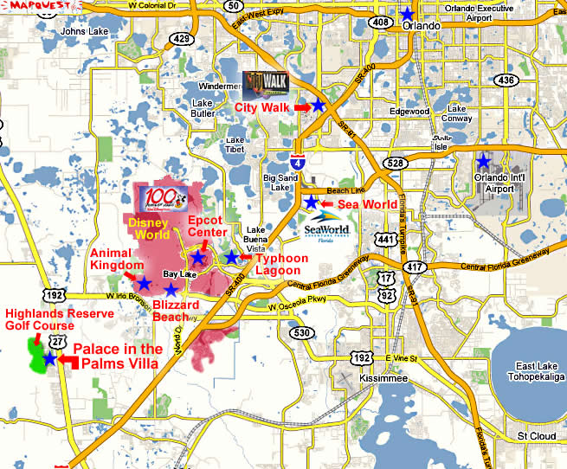
You are at Highland Reserve Golf Course, and you need to get to City walk; How do you get there?
________________________________________________________________________________________________________________________________________________________________________________________________________________________
You’re at St. Cloud, and you need to get to Animal Kingdom; How do you get there?
________________________________________________________________________________________________________________________________________________________________________________________________________________________
You’re at Orlando Excutive Airport, and you need to get to Sea world; How do you get there?
________________________________________________________________________________________________________________________________________________________________________________________________________________________

