HOW DO I GET THERE?

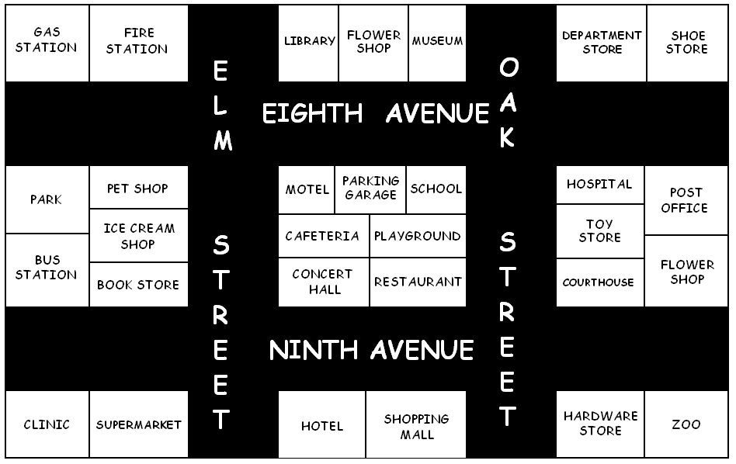

Mr. and Mrs. Lee are very busy today. They want to go to several places with their children, but they don’t know the city very well.

- They’re at the shopping mall, and they want to take their children to the toy store to buy them a new toy. Tell them how to get there.

Walk along Ninth Avenue to Oak Street and turn left. Walk up Oak Street and you’ll see the toy store on the right, across from the playground.

- They’re at the Toy store, and now they want to take their children to the pet shop to buy them a dog.
_______________ Oak Street to Eighth Avenue and __________________________.
_____________ Eighth Avenue and you’ll see the pet shop _______________________
________, ______________________________________________ the fire station.
- They’re at the pet shop, and they want to go to the restaurant to eat something.
_________________________________________________________________________________________________________________________________________________________________________________________________________.

- They’re at the restaurant and they want to relax in the park.
_________________________________________________________________________________________________________________________________________________________________________________________________________.
- They’re in the park and now they want to take their children to see the animals in the zoo.
_________________________________________________________________________________________________________________________________________________________________________________________________________.
- From the Zoo they want to see more work of art at the museum.
_________________________________________________________________________________________________________________________________________________________________________________________________________.
- Now they decide to go to the Bookstore to buys some novels for grandma.
_________________________________________________________________________________________________________________________________________________________________________________________________________.

- They also want to buy some flowers for Grandma’s Birthday, tomorrow.
_________________________________________________________________________________________________________________________________________________________________________________________________________.

- They wish to have some ice cream, before they head of home.
_________________________________________________________________________________________________________________________________________________________________________________________________________.

- They had a wonderful day, and now it’s time to go home. Tell them how to get to the bus station.
_________________________________________________________________________________________________________________________________________________________________________________________________________.

