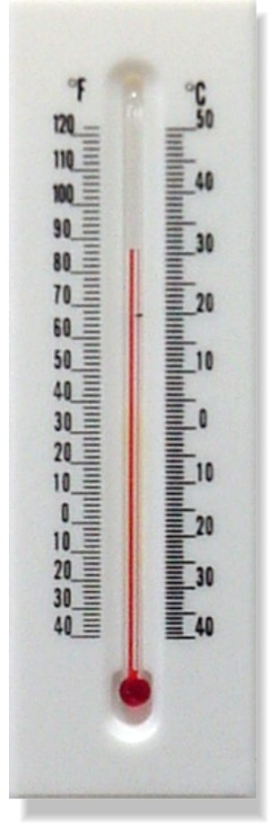

HOT = 90F & UP.
WARM = 74F – 88F
COOL = 52F – 70F
COLD = 50F – 30F
FREEZING = 28F & UNDER
HOT = 30C &UP
WARM = 14C – 28C
COOL = 4C – 12C
COLD = 2C - 0C
FREEZING = -2C & UNDER

